Student Information - How to access TEAMS from home and upload a file to submit an assignment.
- Open your browser (Chrome, Internet Explorer etc.)
- Type www.office.com in the browser
- Click sign in
- Put in your school email address xxxx@holyfamily.ie and your password
- Select the TEAMS app (see below)
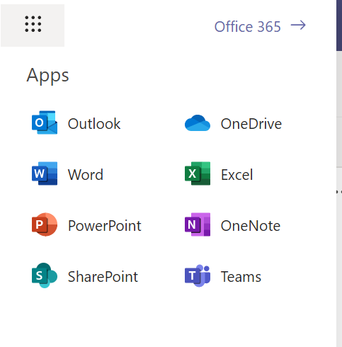
- Select the TEAM where your teacher has put the assignment
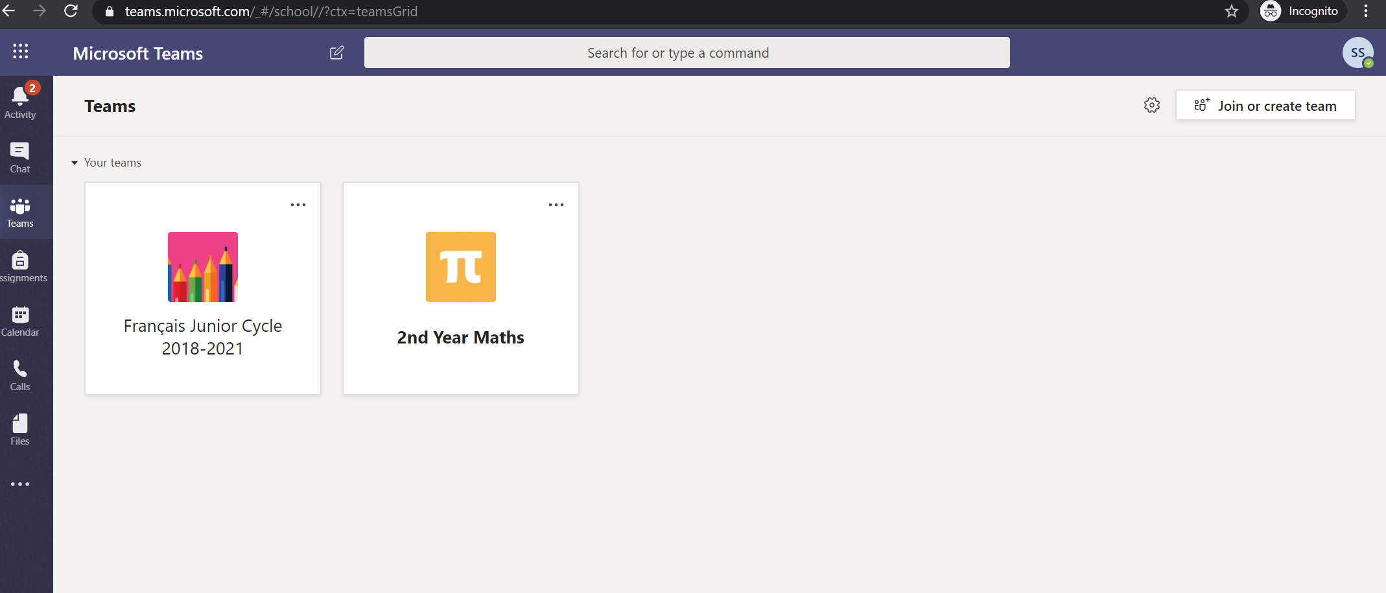
- Select the assignment you have been given
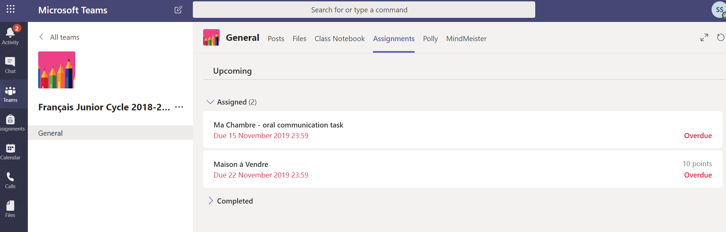
- Click on the assignment to view the details and hand in your work
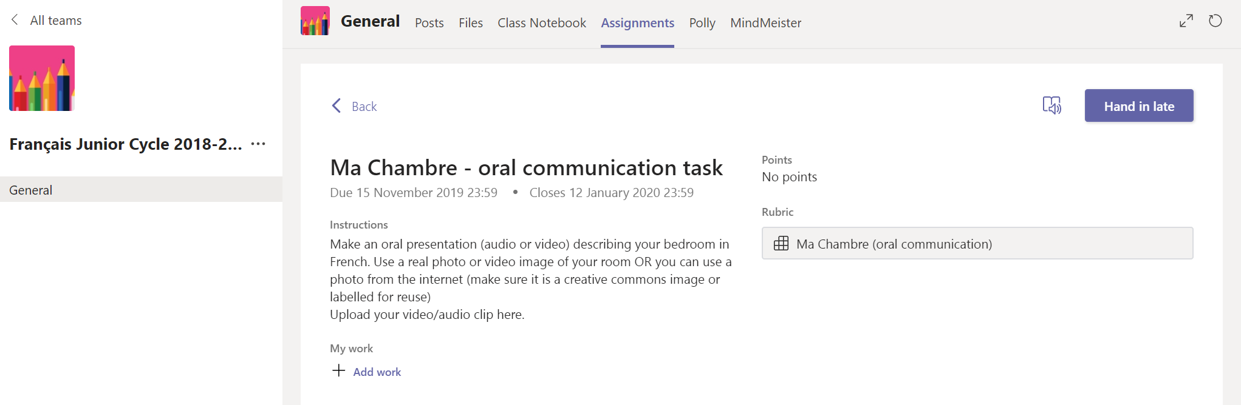

- Click + Add work (new window opens -see below)
- Option 1: Upload a file saved on your One Drive
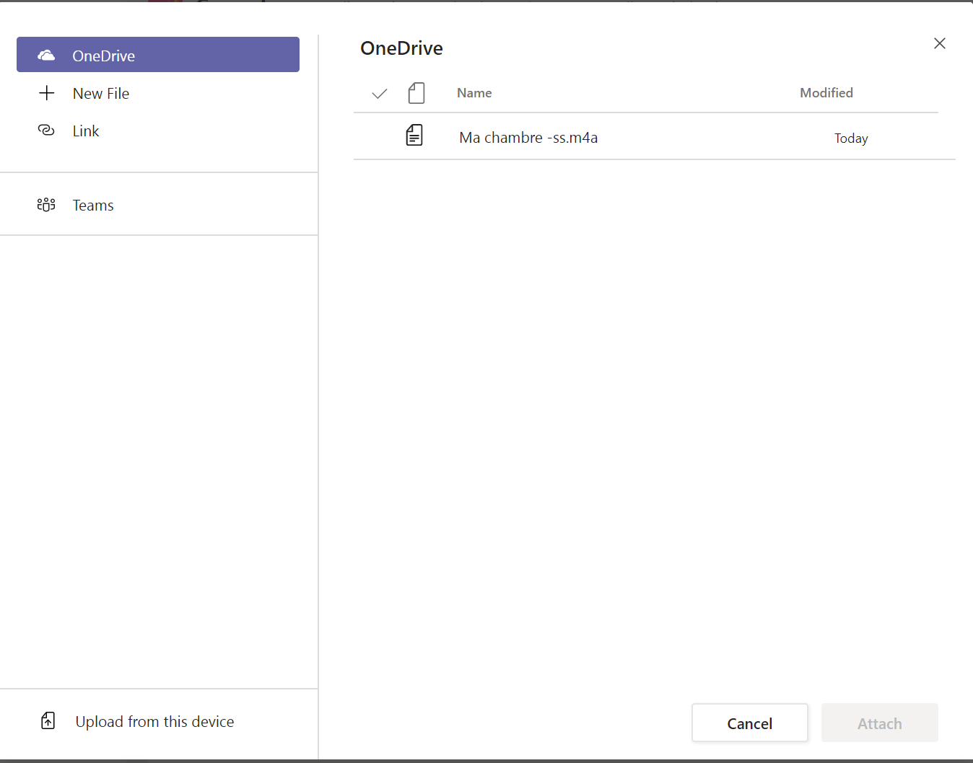 | There are four options to attach a file:  - You can upload a file that you have saved already in your One drive (as shown here on the left)  - You upload a file from the computer (if you have saved the file on your device).  - You can also create a new file by clicking + New File  - You can upload a link

Option 2: Upload a file from the computer/device you are using…
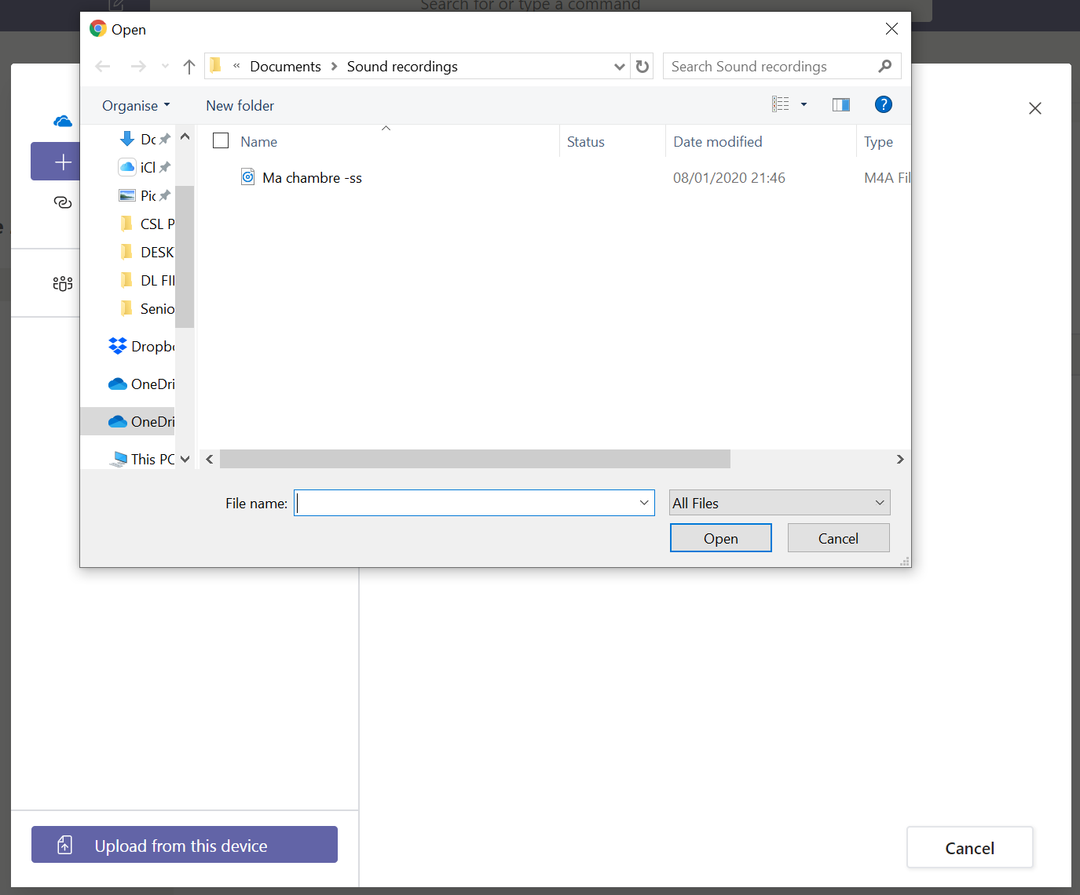

Option 3: Create a New File to upload (Word, Power point, Excel only)
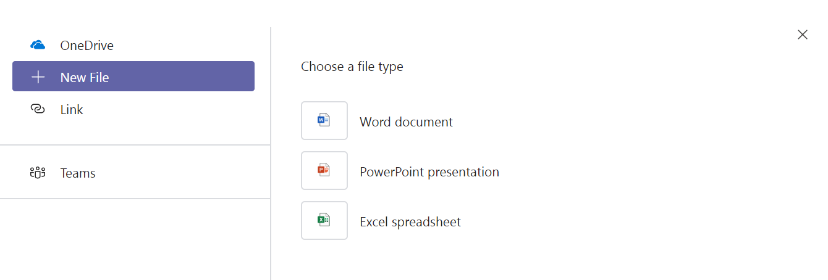

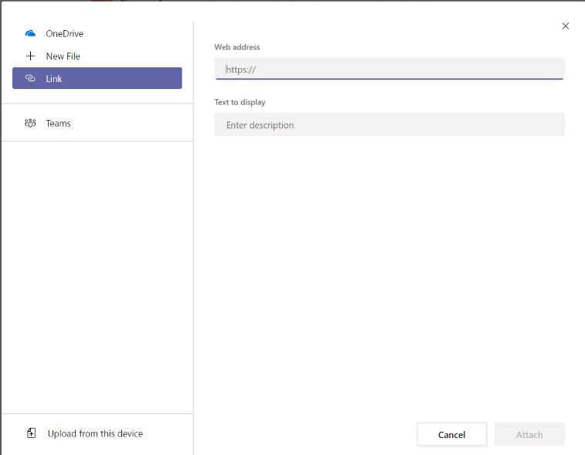
Option 4: Copy & paste a link from another location (type or copy + paste the link in here)

- Click attach to submit your file to the TEAMS assignment
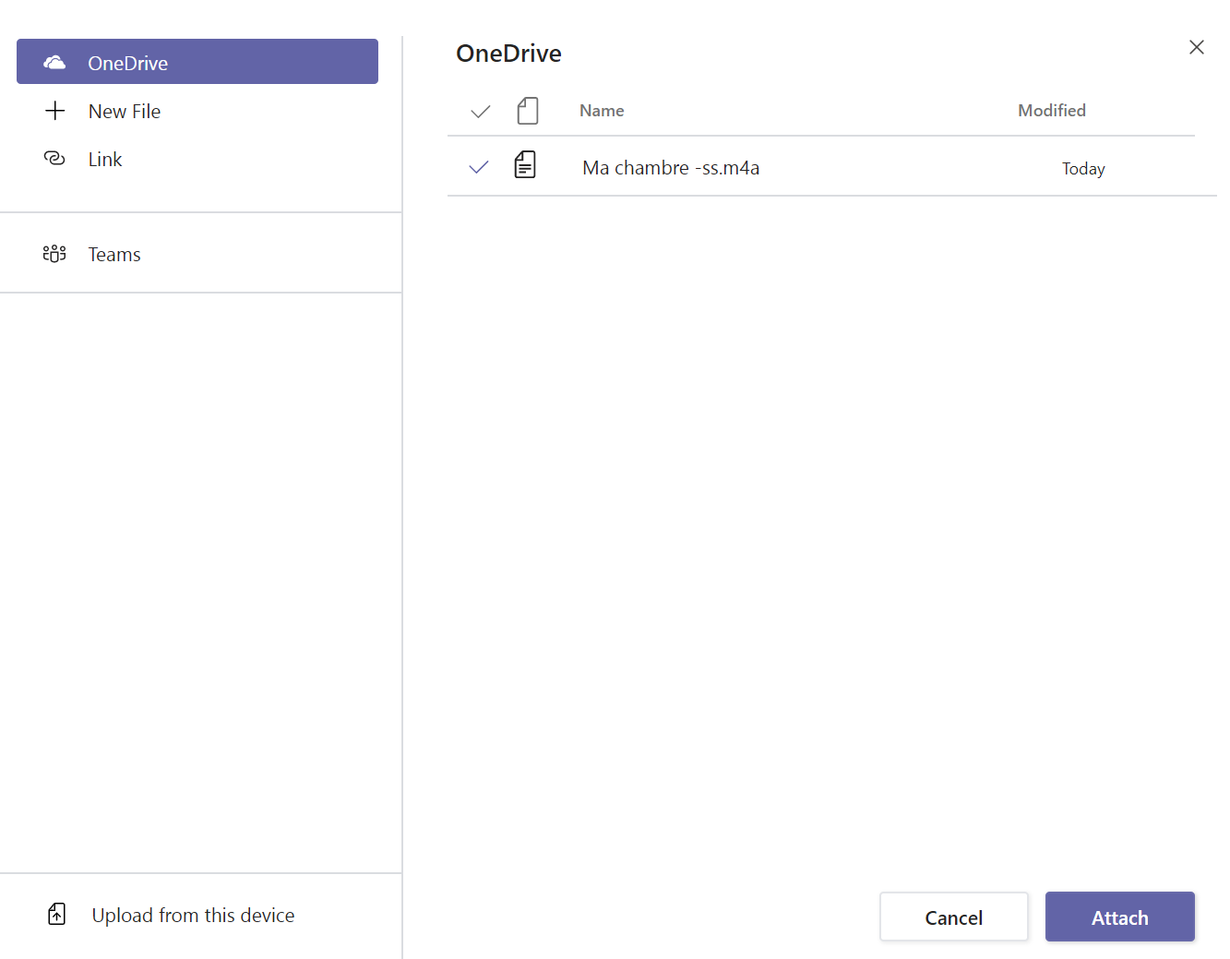

- Click Hand in Late (this assignment is overdue)
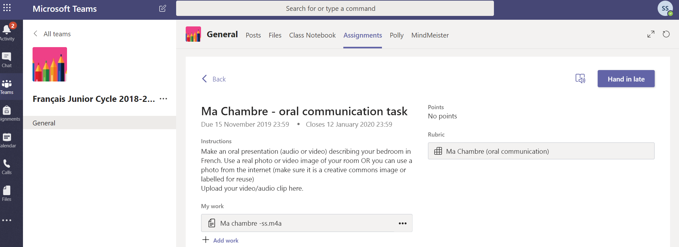
- Your work is now attached and handed in for the teacher to see. If you need to re-do it click Undo Hand it and repeat the process.
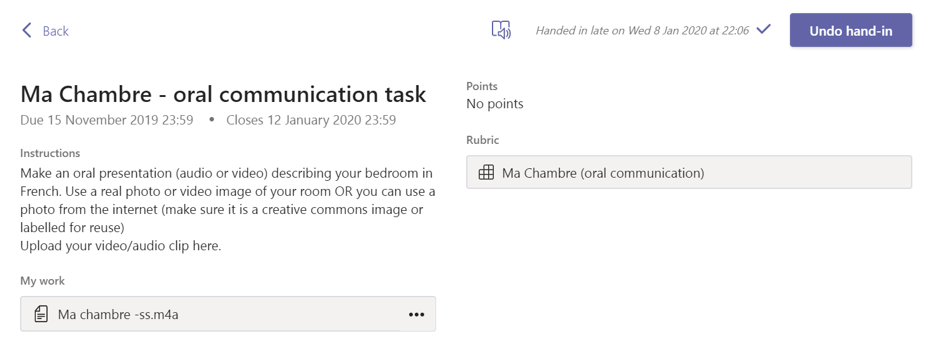
- When the teacher has graded your assignment, you will get a notification in TEAMS. Click on activity to see your feedback and any other information like marks or rubric grading the teacher provides. You can see the feedback and the points below. If there is a rubric, click on it to see where the teacher placed this piece of work.

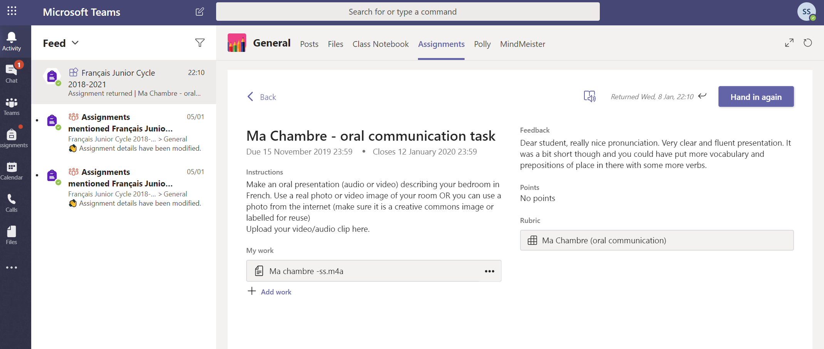

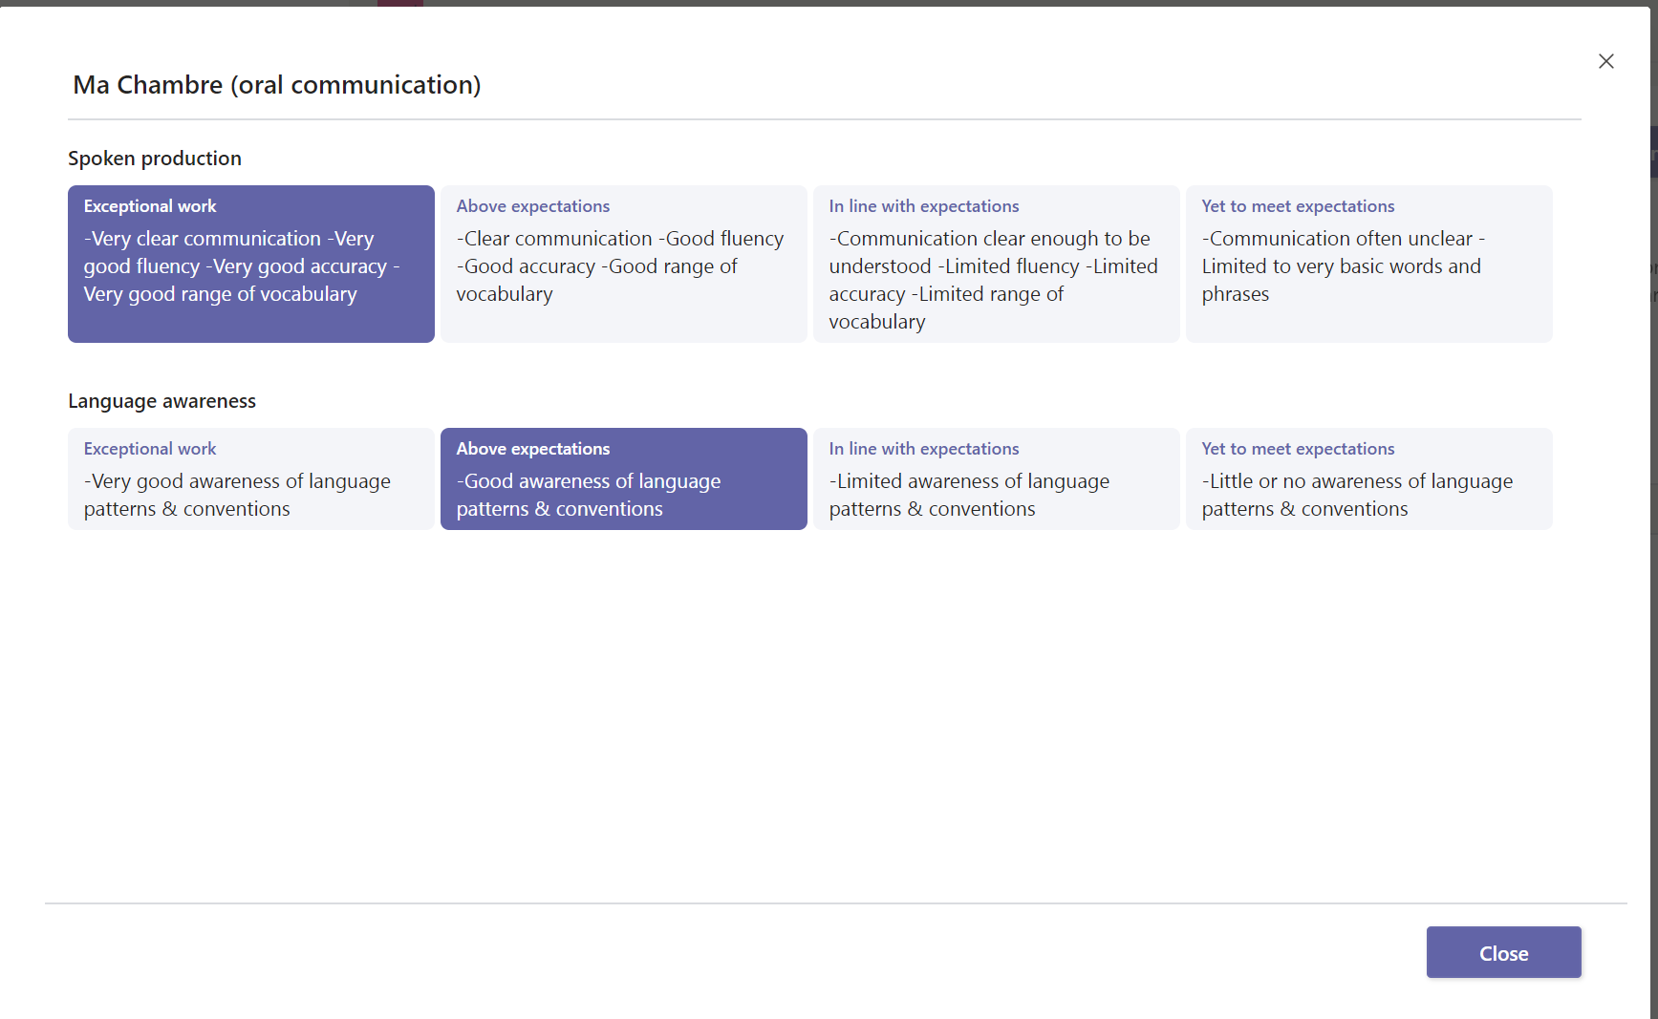

- You can now read the feedback from your teacher alongside your descriptor and marks. If your teacher has told you to use the feedback to improve your work, you can make an improved version of this work and re-submit it to the teacher for further feedback. Attach a New File + New File and click Hand in Again
